•Ministry of Education and Sciences of the Russian Federation • Russian Academy of Sciences
• Commission of the Russian Federation for UNESCO
• UNESCO Institute for Information Technologies in Education • Government of Saint-Petersburg
• Council of Rectors of Saint-Petersburg Higher Education Establishments
• Russian Foundation for Basic Research • United National Aerospace University• Saint Petersburg State Polytechnical University
• Saint-Petersburg State University of Aerospace Instrumentation (SUAI) • UNESCO Chair «Distance Education in Engineering» of SUAI
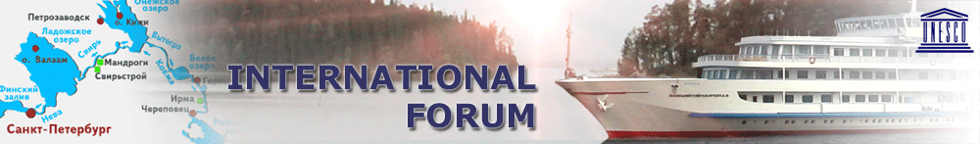
MODERN INFORMATION SOCIETY FORMATION:
PROBLEMS, PERSPECTIVES, INNOVATION APPROACHES

1-5 June, 2015, St.- Petersburg, RUSSIA

The first call for papers

The XVI International Forum «Modern information society formation: problems, perspectives, innovation approaches» will be organized in the period from June 1 to June 5, 2015. It will take place on the board of the comfortable cruise ship cruising from Saint Petersburg with stops at Kizhi Island, Petrozavodsk and Valaam Island by the rivers Neva and Svir, lakes Ladoga and Onega which are the pearls of the Russian North-West region.

In the frame of the International Forum will be organized the following:

- THE V INTERNATIONAL CONFERENCE OF THE UNESCO IITE AND NETWORK OF UNESCO CHAIRS ON ICT IN EDUCATION AND INNOVATIVE PEDAGOGIES
- THE XVIII CONFERENCE FOR YOUNG RESEARCHERS ON WAVE ELECTRONICS AND ITS APPLICATION IN INFORMATION AND TELECOMMUNICATION SYSTEMS
- ROUND-TABLE “ANALYSIS OF THE STATE AND PROSPECTS OF EDUCATIONAL AND RESEARCH ACTIVITIES IN AEROSPACE UNIVERSITIES”
- ROUND-TABLE “INTEGRATION OF INDUSTRY, SCIENCE AND EDUCATION IN MODERN CONDITIONS”
- ROUND-TABLE “QUALITY OF LIFE AND SUSTAINABLE DEVELOPMENT”
- ROUND-TABLE “HUMANITARIAN ANALYTICS OF CONTEMPORANEITY. THE LANGUAGES OF CULTURE’S LANGUAGE”

Organizing committee of the International Forum
Saint-Petersburg State University of Aerospace Instrumentation,
67, B. Morskaya Str, St.-Petersburg, 190000, RUSSIA
Tel.: +7 (812) 312-09-37, Fax: +7 (812) 312-06-58,
e-mail: int@aanet.ru

Preliminary schedule of the trip
June 1, 2015 | 01.00 p.m. | Departure from St.-Petersburg
June 2, 2015 | 08.00 p.m. – 10.00 p.m. | Kizhi Island: walk excursion «Kizhi reserve»
June 3, 2015 | 08.00 a.m. – 01.00 p.m. | Petrozavodsk: excursion to waterfall Kivatch
June 4, 2015 | 05.00 p.m. – 09.00 p.m. | Valaam Island: excursion to Valaam Monastery
June 5, 2015 | 08.00 a.m. | Arrival to St.-Petersburg

Preparation of Abstracts

The abstracts are submitted in *.DOC and *.RTF formats in English and Russian (if possible) languages. Parameters of the text editor: paper size - A4, fields - 2 cm, book orientation, font - Times New Roman, font size - 14, new paragraph – 1,25 cm, line spacing – single, alignment – justified, hyphenation – automatic.

Text formation: title; initials, surname, scientific degree and position of the author; country, city; organization's full name; text of the abstract; contact information: contact phone number and/or e-mail address of the author (see example).
The deadline for abstracts submission is 15th of April, 2015.

Presentation Preparation

Official presentation format: PowerPoint (2010 or earlier versions). *.PDF or *.ODF are also acceptable.

Suggested parameters for presentation: size of fonts - not less than 12 , color scale - light background (closer to white), dark letters (dark blue, dark red, black, etc.). Multimedia components (video, audio-fragments) used in the presentation have to be duplicated in the form of separate files.

Participation Cost
The participation cost amounts to 800 USD (650 USD for spouse). This includes the registration contribution, abstracts publishing, accommodation on board of the comfortable cruise ship, 3 meals a day, excursions and cultural activities during the Forum.
Please, pay for account № 40503840900090090001
Bank’s name : Saint-Petersburg branch Rosdorbank
Address: 2, lit.A, Manezhniy per., Saint-Petersburg, Russia, 191028
SWIFT: ROSORUMM
via correspondent account:
№ 04415764 in Deutsche Bank Trust Company Americas, New York, USA
SWIFT: BKTRUS33
in favour of St. Petersburg State University of Aerospace Instrumentation
with the reference: Participation fee, International Forum.
Please, note: all banking charges should bе covered by payer.

Brief information about the cultural program

ISLAND VALAAM. Valaam Monastery.
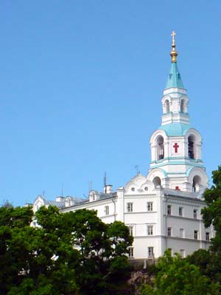
The island of Valaam within an archipelago of islands in the Ladoga Lake does deserve its world fame. The island hosts a functioning friary with its chronicle dating back to the X century, Spaso-Preobrazhensky Cathedral, the St.Peter and Paul Church and several skits that preserve spiritual values and are magnificent monuments of Russian architecture. Besides all this are combined with the island’s unique nature.

ISLAND KIZHI. Reserve of Kizhi.
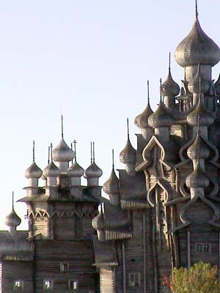
This small island is a unique quarter of the Russian land in the Onega Lake where the famous ensemble of Kizhi temples is located, including over 80 monuments of wooden architecture, created by old masters several centuries ago.
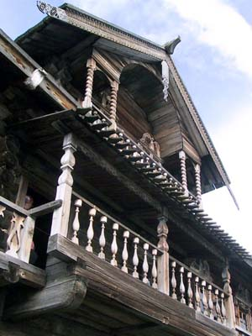
The Church of the Transfiguration (1714) is a world masterpiece of wooden architecture. Five tiers of 22 domes, wonderfully changing color during the day, look magnificent from any point of the island.
The iconostasis in the Church of the Protecting Veil was selected from the richest collection of old icons from churches throughout the Onega region.
There is also one of the oldest monuments of Russian wooden architecture, the Church of the Resurrection of Lazarus from Murom Monastery (2nd half of the XIV century).
Since 1993 the museum of Kizhi has been under the auspices of UNESCO.
PETROZAVODSK
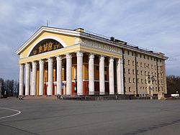
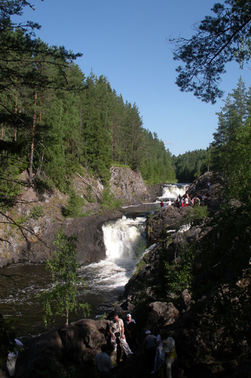
Petrozavodsk is the capital of the Republic of Karelia streching along the western edge of Lake Onega. It is a city with a rich history and exciting present, founded in 1703 to house an iron foundry to manufacture and supply anchors for the Baltic Fleet.

During the captivating bus excursion about 60 km. away from Petrozavodsk you will visit the Kivatch Waterfalls - the natural pearl of Karelia.

Kivatch Waterfall is located on the Suna River, on the territory of the Nature Reserve "Kivatch”. It is the second among the plain waterfalls in Europe by its size - 10.7 m. The water in it falls in cascades from several ledges causing an impression of an unusual power and stream force.
Registration Form

MODERN INFORMATION SOCIETY FORMATION:
PROBLEMS, PERSPECTIVES, INNOVATION APPROACHES
1-5 June, 2015, St.- Petersburg, RUSSIA

1.Title (Prof./Dr./Mr./Ms.) 2.Sex

3.Last name

4.First name

5.Proffession/Position

6.Company

7.Address: Home Office
Street address /PO Box

City

Post/Zip Code Country

Phone Fax Email

8.Passport № 9. Date of birth (dd/mm/yy)

10. Date of issue (date of expiry dd/mm/yy) 11. Valid until (date of expiry dd/mm/yy)

12.Date of arrival to Russia (approximately - this date will be

pointed at your invitation for getting entrance visa)
13.Date of departure from Russia (approximately - this date will

be pointed at your invitation for getting entrance visa)
14.Cities for visiting in Russia

15. City, where you prefer to get you visa (Russian Embassy or Consulate should be there)
16. Are you coming with accompanying person? YES Name of the accompany person:

NO

17. Do you plan to submit paper? YES
NO

